

Computer System Engineering Department

ENEE3309

COMMUNICATION SYSTEMS

-**Project Phase Two-**

Prepared by:

1. **Mohammad Qady Student NO.**1211099

Instructor: Dr. Qadri Mayalla

Sec: Three

1. **Abd AlRahman Shaheen Student NO.** 1211753
2. **Mahmoud Awad Student NO.** 1212677

Instructor: Dr. Ashraf Al-Rimawi

Sec: Two

Date: 20_1_2024

Table of Contents

**Table of Contents** I

**Table of Figures** II

**Introduction** 0

**Results:** 0

**Using Pspice:** 0

**Using Tinkercad:** 1

**Result's Discussion:** 2

**Circuit Design:** 2

**Simulation and Breadboard Implementation:** 2

***Key Findings:*** 2

**Conclusion:** 2

Fig.1:modulated signal using PSpice software 0

Fig.2: demodulated using PSpice software 0

Fig.3 :modulated signal using TinkerCad software 1

Fig.4 :demodulated signal using TinkerCad software 1

# **Introduction**

In this project, amplitude modulation (AM) by designing, simulating, and constructing AM circuits using a switching modulator, a bandpass filter, and an envelope detector.

Executed in two distinct phases—simulation using Pspice, followed by hands-on construction on a breadboard with an oscilloscope using Tinkercad. The project Emphasizing theoretical analysis, practical implementation, and the utilization of modern engineering tools, for skill development in circuit design and experimentation.

# **Results:**

## **Using Pspice:**

1. 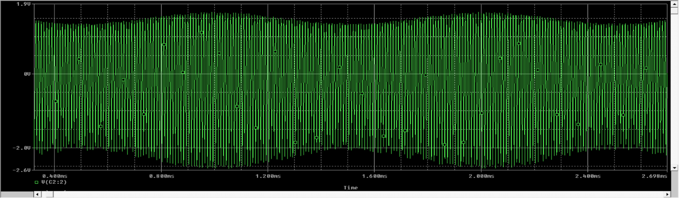**Modulated signal**

Fig.1:modulated signal using PSpice software

1. 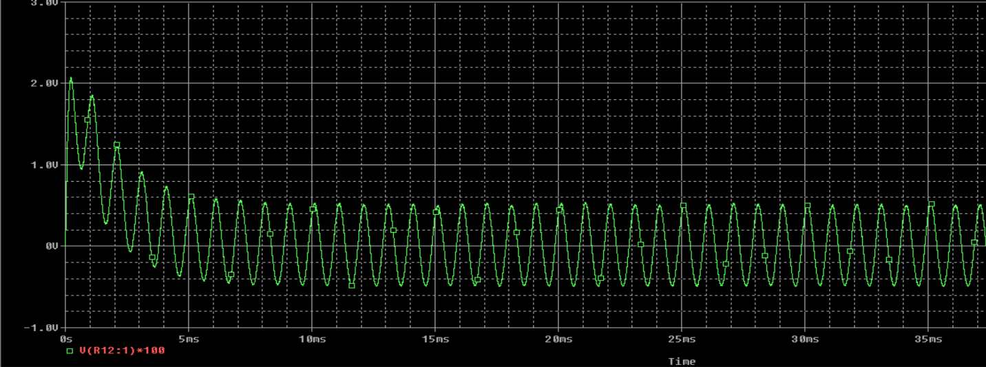**demodulated signal**

Fig.2: demodulated using PSpice software

# **Using Tinkercad:**

1. **First Circuit:**

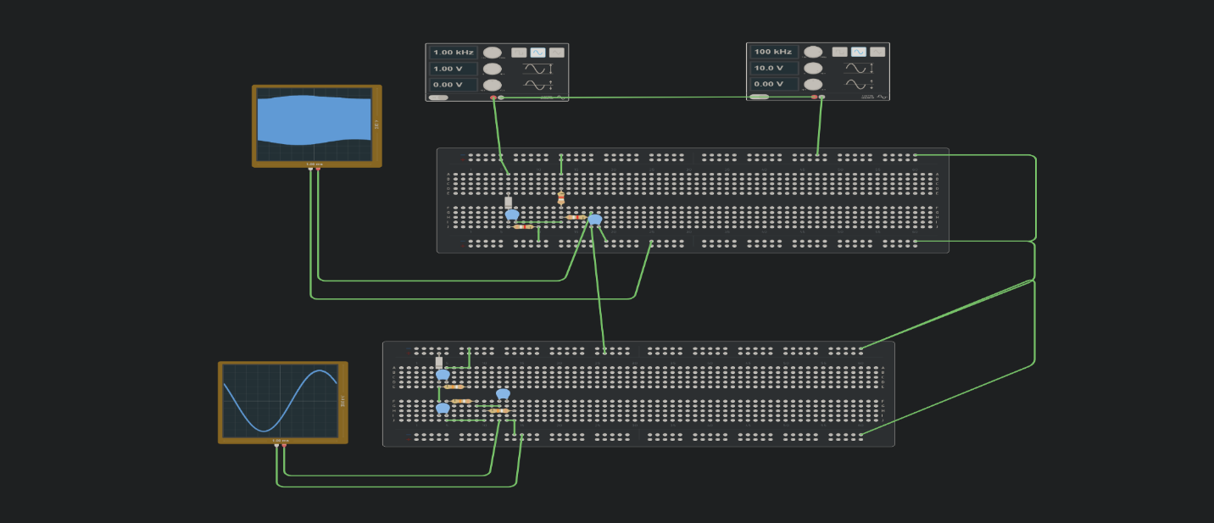

Fig.3 :modulated signal using TinkerCad software

1. **Second Circuit:**

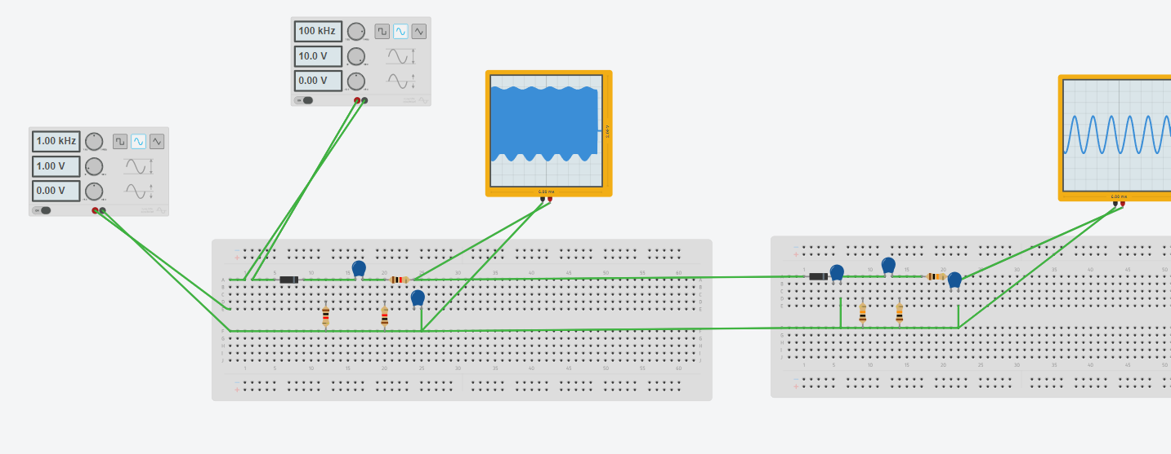

Fig.4 :demodulated signal using TinkerCad software

# **Result's Discussion:**

## **Circuit Design:**

* **Modulator:** We choose a switching circuit due to its simplicity and effectiveness in creating AM signals. To isolate the desired modulated signal and eliminate unwanted frequencies, a bandpass filter was designed.
* **Demodulator:** A good choice we considered, is an envelope detector circuit. due to its ability to efficiently extract the original message signal from the modulated wave.

## **Simulation and Breadboard Implementation:**

* **Tinkercad Breadboard:** We constructed virtual versions of both circuits using Tinkercad's breadboard interface.
* **Oscilloscope Analysis:** We accurately examined the simulated waveforms to visualize the modulation and demodulation processes.

## ***Key Findings:***

* **Verification:** The close agreement that the simulated and the breadboard results validates our circuit designs and understanding of AM principles.
* **Filter Design:** The implementation of additional filtering showcases a practical approach to overcoming non-idealities and enhancing signal quality.

# **Conclusion:**

This project has provided us with a comprehensive understanding of amplitude modulation through a hands-on approach. We have successfully designed, simulated, and implemented AM circuits, addressing real-world challenges and exploring potential solutions. Our findings underscore the importance of practical experimentation and the value of addressing non-idealities in circuit design.